**Analysis of Crime**

**2020 & 2021**



# Abstract

Crime analysis is made for the reported crimes in Leicestershire and Essex for the year 2020 and 2021. The data is gathered from data.police.uk. Yearly analysis for individual force, between the forces, type of crimes, monthly trends and geographical illustrations are shown. The report focuses on the crime rate, reasons that could fall behind the crime rate, types of crime that are mostly seen and impact of Covid’19 on crime rate. The report depicts useful insights which can be used for future analysis. Moreover, report highlight the crimes which are most often and its trends across the months.

Table of Contents

Abstract 3

Introduction 5

Data Source and License 5

Data Format 5

Data Scope and Range 5

Data Accuracy 5

Methodology 6

Initial Steps 6

Data Cleansing and Preprocessing 6

Analysis 9

Exploratory Analysis 9

Yearly Based 9

Monthly Based 9

Crimes Based on Type 11

Data visualisation 12

Crime rate over months 12

Crime rate over forces 12

Time Analysis 13

Geographical Analysis 15

Conclusion and Future Research 16

References 17

Appendix 18

Appendix 1 18

Bicycle theft 18

Blaby 013C 18

Burglary 18

Charnwood 012C 19

Charnwood 021E 19

Charnwood 022D 19

Criminal damage and arson 19

Drugs 20

Other crime 20

Other theft 20

Possession of weapons 20

Public order 21

Robbery 21

Shoplifting 21

Theft from the person 21

Vehicle crime 22

Violence and sexual offences 22

# Introduction

## Data Source and License

The data is present on data.police.uk. The data contains crime information occurred in different areas in England and Wales. Data is accessible to all the people, so they can easily download the files and use to get insights.

The data present on the source is under the license. The data is published by Home Office which is previously gathered from UK’s police forces. Its then published under UK’s open government license for usage. Copying, publishing, disseminating, and transmitting information is allowed under the license. The data used in this report is fetched from data.police.uk for two years (2020, 2021).

## Data Format

The data present on the source comprises of CSV files. Each file contains data for the entire month. Moreover, the data is particular for the crimes being attempted in geographical location. For each file, there are multiple rows that shows the crime information along with the location fields (Latitude, Longitude), type of crimes and crime reported date (month). The primary focus of report is on the above fields.

## Data Scope and Range

The data present in this report lies within two years. The data is collected for two forces.

One is Leicestershire police and other for the Essex police. The report is based on crime data collected from January, 2020 till December, 2021; inclusively.

## Data Accuracy

The data gathered is not entirely based on the crime, made in specific location. This could be reported to other forces as well. For instance, the crime could be committed outside the Essex but it can be possibly reported to Essex police or to Leicestershire police or any other force.

As the data is published back and forth, there are chances of data duplication and inconsistency. So, this is possible that crime records may get repeated.

Moreover, if location for a crime is not known so far, the inaccuracy could be seen.

In order to cope up with this, those rows are removed from the data.

# Methodology

## Initial Steps

The CSV files containing crime data were downloaded from data.police.uk for the two forces i.e. (Leicestershire police, Essex Police). These files were then uploaded to HDFS using web console. First, a new python file was created in Jupyter. Then, the main libraries were imported for the initializing the spark context. After this, RDD was created from the imported files.



Figure 1: Loading CSV files

## Data Cleansing and Preprocessing

As forty-eight files were imported, so the RDD includes all the files headers. Extracting one header and removing from all data. A new RDD is created holding data with no more headers.

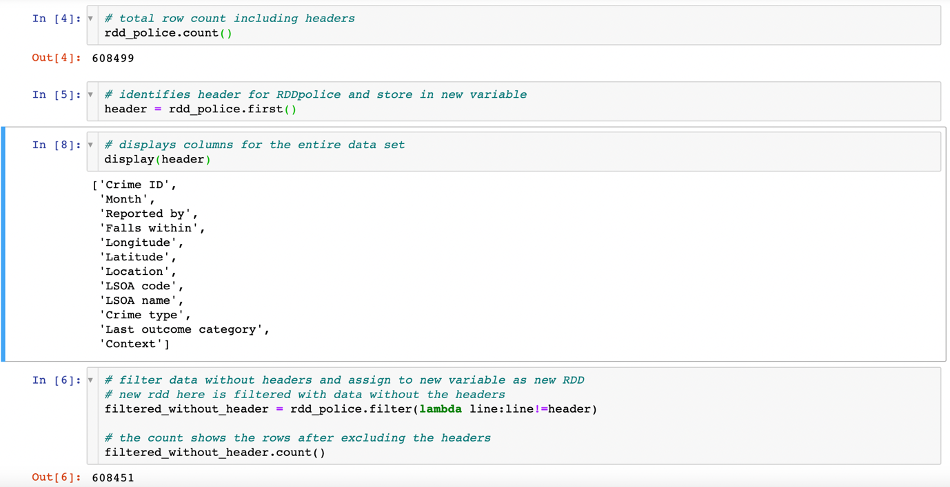

Figure 2: Fetch and removal of headers

As above figure 2 shows, 48 columns for headers are removed.

In figure 3, now mapping the new headers to filtered data from which previously the headers were removed.

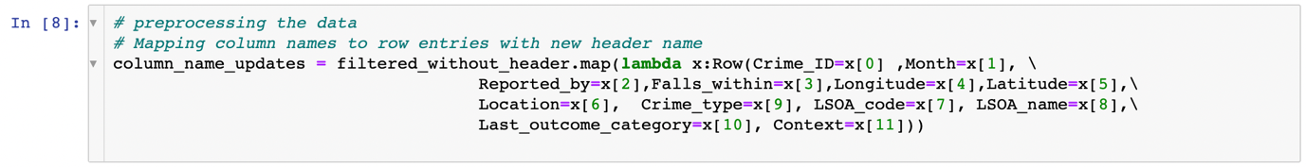

Figure 3: New header updates

The few columns in data consist of empty values. Now removing the rows containing empty strings to make data more consistent in figure 4. The columns names are as follow:

1. Crime_ID

2. LSOA_code

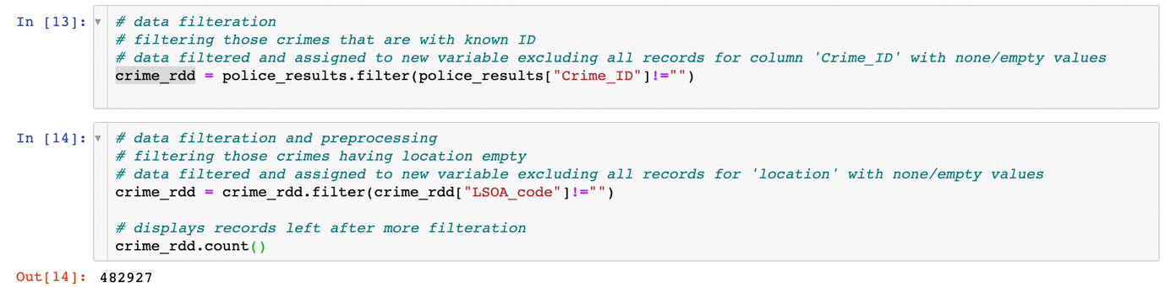

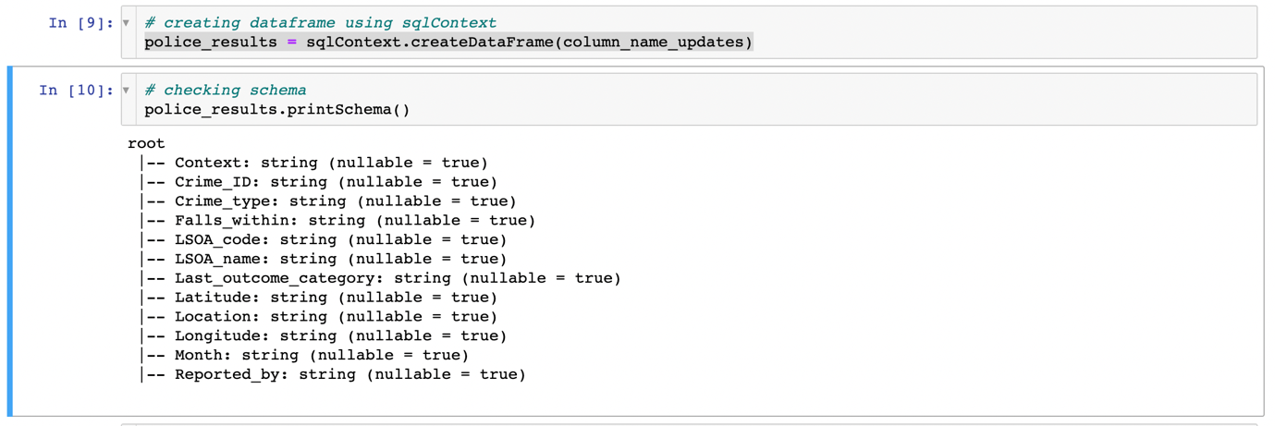

Figure 4: Clean data and print new schema

Now, output data to pandas in order to have better observation of data table.

This can be seen in figure 5.

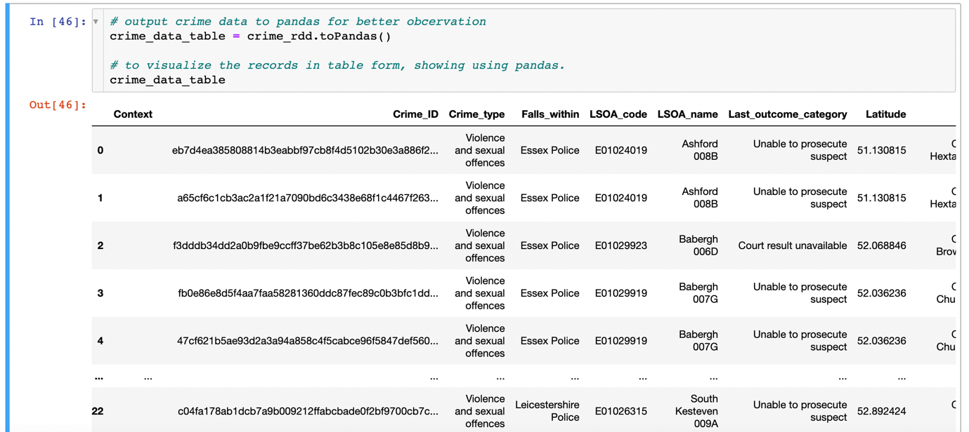

Figure 5: Crime data using pandas

The table shows, all columns have data but the column named ‘Context’ has empty rows. Due to empty values, we do not require this column, dropping this column in figure 6.



Figure 6: Drop context column

Looking deeper into the data, we have two columns consisting of numeric values that has type string. Typecasting these columns to type float for better usability.

The updated schema can be seen after the typecasting in figure 7. The schema shows the column names and data types.

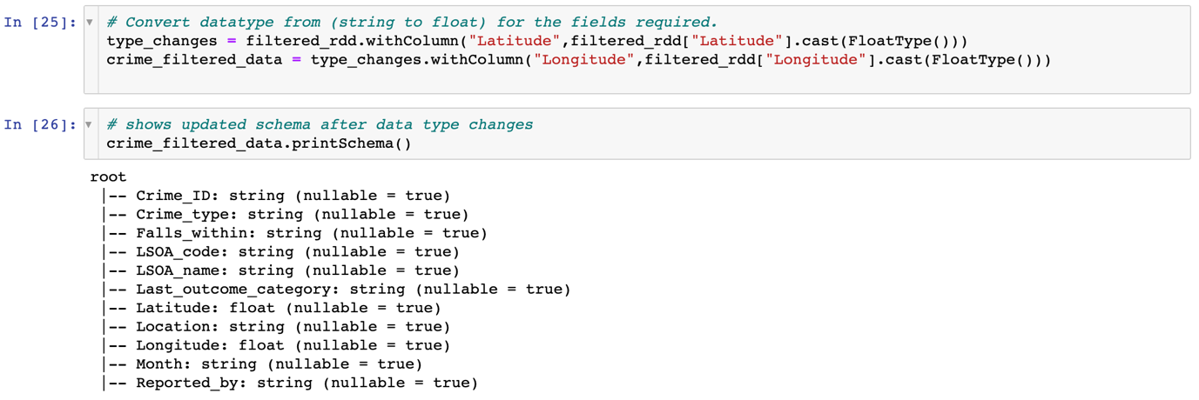

Figure 7: Change data types

# Analysis

## Exploratory Analysis

### Yearly Based

The crime rate varies with passage of time. Total 482927 crimes are recorded for the two years (2020,2021) for both forces (Leicestershire police, Essex police). If we put eye on yearly crime rate for each year for these forces, 247486 crimes took place in 2021 and 235441 took place in 2020. The figures for the both years are close enough, which shows the crime rate didn’t spike high as this was pandemic period.

During Covid’19, we can deduct from the crime cases that crime rate remained around 51% to 53% for both years. If we look into the crime rate based on (cases reported to forces) for two years, we see that 64.96% cases are reported to Essex police where 35.04% cases reported to Leicestershire police. We can conclude from these results that Essex police are reported with far more crime cases rather than Leicestershire one.

### Monthly Based

Using the MySQL queries, results are extracted from the data. Looking deeper, the following illustrations can be made on basis of results.

If we look into the crime cases reported in each month, we can see the difference.

Here below in figure 8, these are total crimes reported to Leicestershire police for two years. From top five months crime count, we see that, at that time domestic Covid restrictions were removed in England, due to which crime count incremented gradually with passage of time.

If we see the last four months from the bottom, they show quiet low count in those months, as Covid restrictions were there.

**Monthly trends for each crime type with respect to outcomes can be seen in Appendix 1 for year 2021.**

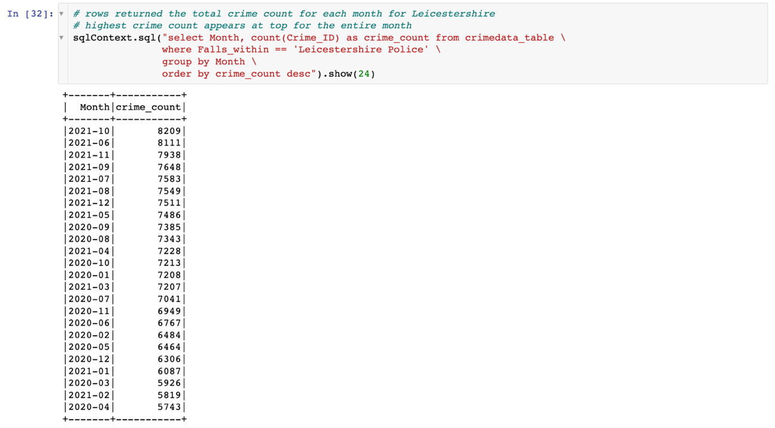

Figure 8: Monthly crime count (Falls within Leicestershire)

Similarly, if we look across crime reported to Essex police, same pattern is observed as like Leicestershire one. The months in which restrictions were made shows less crime count as compared to other months when restrictions were lifted off. The figure 9 shows the crime count, reported to Essex police.

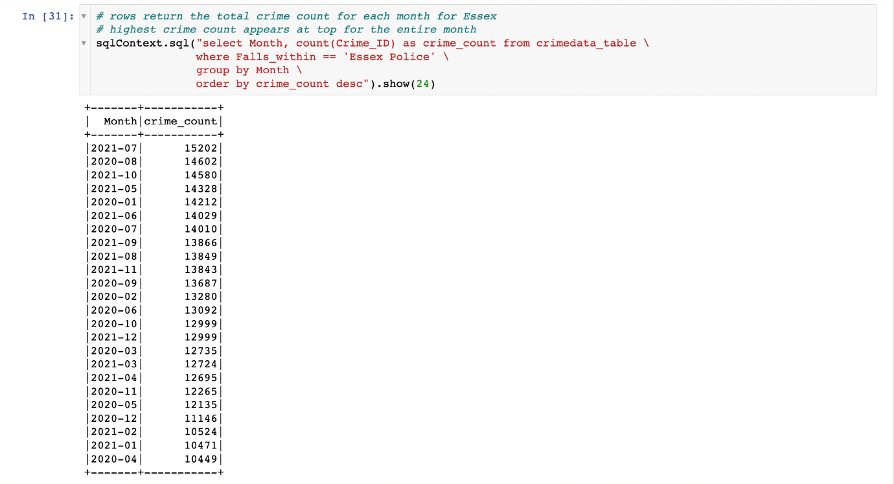

Figure 9: Monthly crime count (Falls within Essex)

### Crimes Based on Type

Looking into the type of crimes, we see that total 17 types of crimes are enlisted.

After getting total crimes on basis of type, here table below shows the top ten types that had high crime count for span of last two years (2020, 2021).

|  |  |  |
| --- | --- | --- |
| Crime Type | Leicestershire Police  (Crime count) | Essex Police  (Crime count) |
| Violence and sexual offences | 71578 | 147931 |
| Public order | 21986 | 33566 |
| Criminal damage and arson | 18763 | 29633 |
| Other theft | 13645 | 20872 |
| Vehicle crime | 11606 | 22482 |
| Burglary | 8446 | 13948 |
| Shoplifting | 6064 | 15256 |
| Drugs | 5988 | 12693 |
| Other crime | 4167 | 6935 |
| Bicycle theft | 2818 | 3270 |

Table 1: Crime type Vs Crime count

The above table illustrates that violence and sexual offences had highest crime rate for the past two years. Cases for this type are reported to both forces. Public order, criminal damage and arson stands on second and third in the table. These top three types of crime are likely to be most common in these regions. If we look in bottom, bicycle theft and drugs crime had lowest rate. This indicates that forces in those regions had better control on these crimes rather than others.

Diving more into the data, crime locations have been identified along with the crime count. These are locations where crime is attempted and it falls under the certain force. The table below shows aggregated statistics for the forces, under which the crimes fall within. Maximum crimes fall within the Essex police, reflecting the maximum number of locations where as figures falling under Leicestershire police stood low.

|  |  |  |
| --- | --- | --- |
| Falls within | Crime count | Total crime locations |
| Essex Police | 313722 | 1810 |
| Leicestershire Police | 169205 | 705 |

Table 2: Crime type Vs Crime count

This query is used to get the above results. The “LSOA_code” column known as a location code is used to get unique locations and crime count on its basis. It can be seen in figure 10.

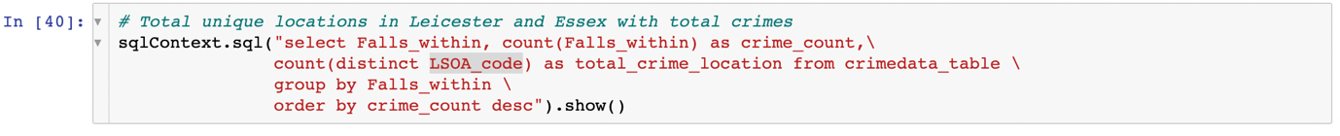

Figure 10: Filtering on basis of location code

## Data visualisation

### Crime rate over months

Data can be visualised using many tools. In order to dive deeper, data is explored more using “Pixiedust”, a library used for visualisation using data frame.

These below are combined results for both the forces.

The below pie chart illuminated that between January 2020 and December 2021, the monthly recorded crimes remained around to maximum 6% for few months whereas crimes fell significantly when lockdown was imposed during the pandemic. The lowest percentage of crime can be seen in the first and second quarter of both the years as 4%.

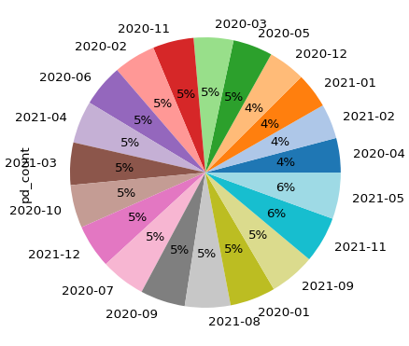

Figure 11: Pie chart showing monthly crime percentage

From January 2020 until March 2020, the crimes rate remained the same, as the first lock down in England was not imposed at that time. With start of lock down, crime rate gradually increased and remain stood at 5% for the next few months.

If we look post pandemic months, in April 2021 we see the crime rate increased to 6% as 2nd imposed lock down was removed, national restrictions were lifted off whereas vaccination process was being carried out.

### Crime rate over forces

Expanding data exploration on the forces, it signifies that the Essex police have been reported for the far more cases rather than the Leicestershire police. If we look into data set, each crime is linked with the location and the force. From this, this can be analyzed that Essex region has more crime ratio.

Below pie chart figure 12 shows the distribution of crime percentage among the forces for the year (2020, 2021).

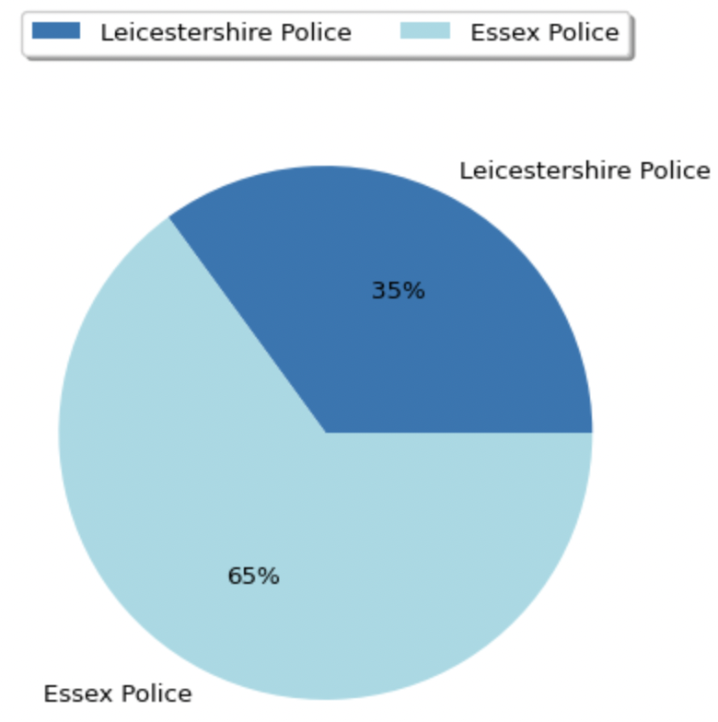

Figure 12: Pie chart showing crime distribution w.r.t forces

### Time Analysis

Here figure 13 below shows the crime types and their variation over the time. The bar chart illustrates about the type of crime that occurred most frequently. Violence and sexual offences can be seen really high over the past months. This crime peak months were after June 2021, crossing 2500 cases per month, which indicates as once covid restrictions were removed, the crime cases increased apparently. Other type of crime cases remained low, no more than 1500 per month. This ensure us that others crimes are controlled but violence and sexual offences are not. The forces must need to take action to minimize these cases.

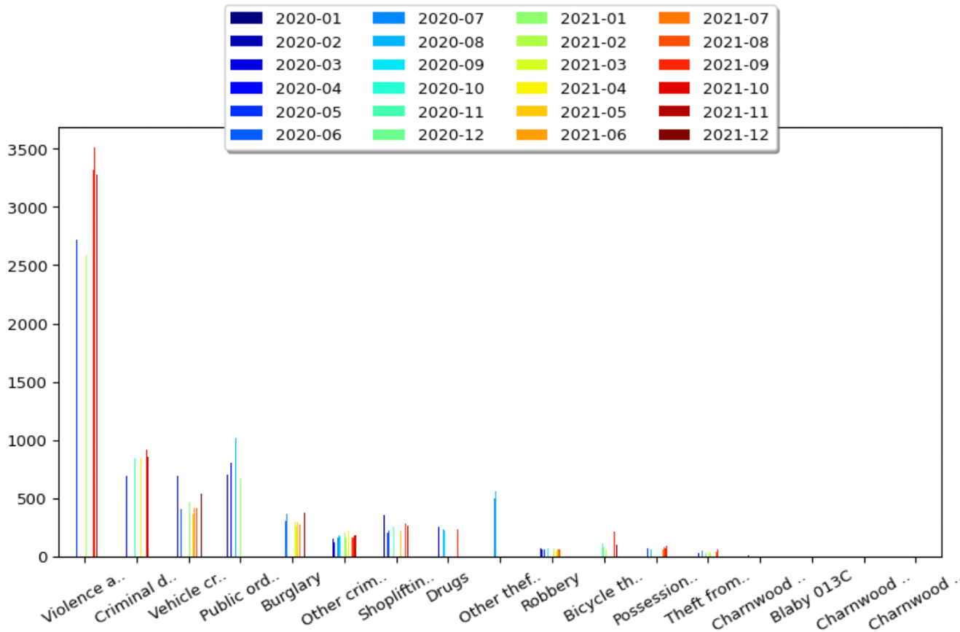

Figure 13: Bar chart showing crime type monthly rates (falls within Leicestershire)

Below figure 14 indicates crimes on basis of types. Essex police was reported for these cases.

The crime pattern is almost identical to the one seen for other force above, but cases are double. Most probably, Essex region comprises of plenty of towns and large amount of population. For the past two years, violence and sexual offences has been recorded 39.4%, public order as 8.8% and criminal damage as 7.3%. **Looking deeper, we see that as second imposed lock down as removed in April 2021, several crime rates increased i.e. (shoplifting, other thefts, robbery, theft from the person).**

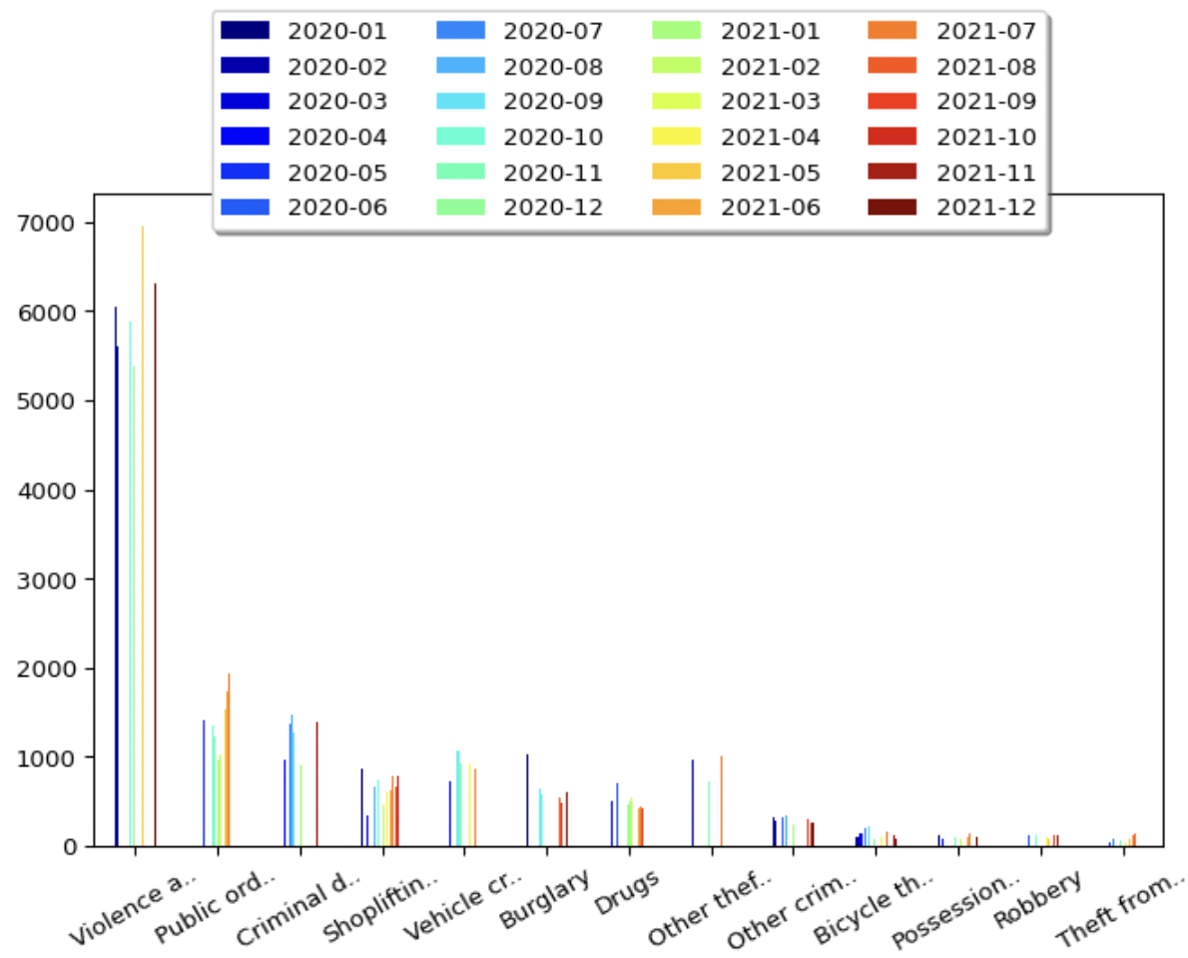

Figure 14: Bar chart showing crime type monthly rates (falls within Essex)

Line chart in figure 15, shows the crime trends over the past two years. Same pattern is followed for the both forces. Beginning from January 2020, the crime rate decreased over the first four months due to first lock down, then as some restrictions were removed, crime rate started to rise again till August of 2020. Moving ahead, downward trend can be seen till March 2021. In addition to this, irregular spike can be seen around in October breaking the past trend. This trend is followed in both line charts.

Moreover, the line chart illustrates about the continuous crime trends from second quarter of 2021 till end of year.

**It is interesting to note that cases dropped from November till January mid. Changes in climate could be a reason that affects the crime rate. Usually, in winters people stay at home, enjoy Christmas break. This rate then increases again in summer.**

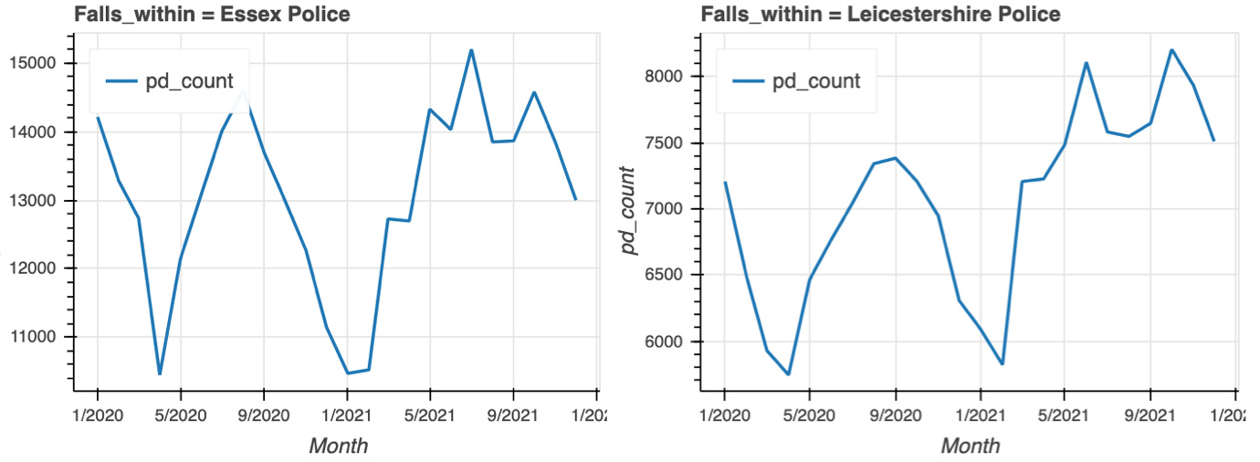

Figure 15: Line chart showing crime trends for two years

### Geographical Analysis

The crimes committed are not targeted to the specific region, as it can be committed anywhere else and reported to respective force. So, the location might differ. Crime types are mapped here to visualize the interesting patterns. Density maps are added below to identify the locations with maximum crime rate and crime type.

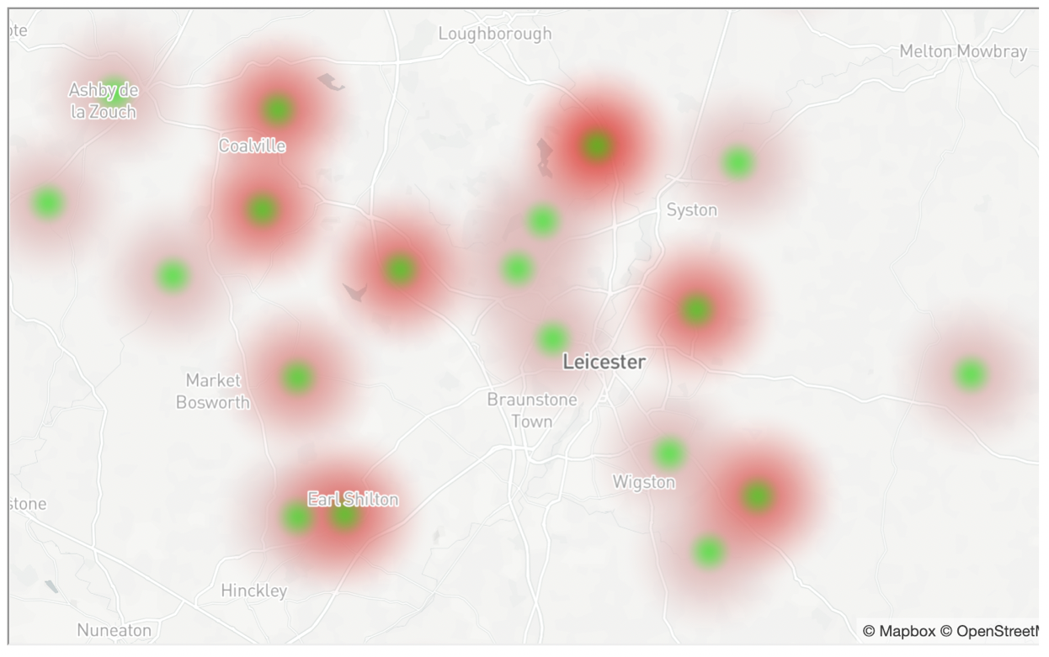

Figure 16: Density map showing high rated crime areas in Leicestershire

Hovering over the highest shaded areas, its shows the violence and sexual offences occurred on or near Hawthorn Road. Near De Montfort University, other thefts can be seen near or on parking area. Most vehicle crimes are seen near the hospital in Leicester.

In Loughborough, bicycle theft and vehicle crimes are mostly observed. **Forces in this region should inform students and community to take vehicle training and theft awareness lessons**.

Similarly in a figure 17 below, the density map of Essex can be seen.

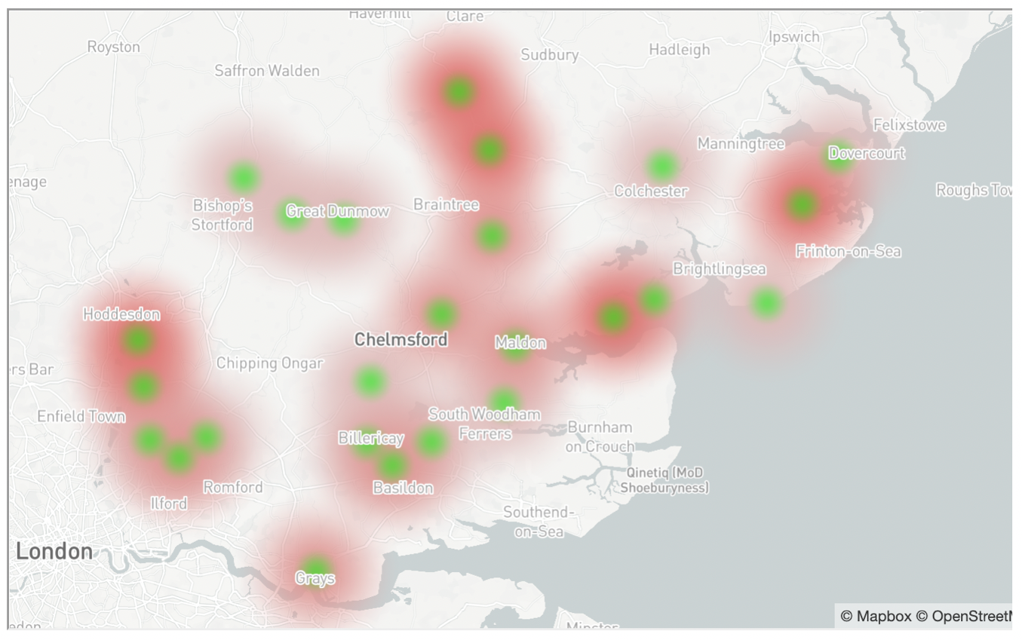

Figure 17: Density map showing high rated crime areas in Essex

Violence and sexual offences occurred at most of locations such as near Queen Anne Road.

**Most drugs crimes made in Colchester near University of Essex and near Hythe station road, which indicates that majority of students could be involved in this**. Essex force should come up with new plans to reduce the crime rate.

## Conclusion and Future Research

Throughout the analysis, we have discovered crimes trends across years, across different locations and forces. Moreover, we have found, crime types that varied geographically.

Discussed the reasons that could be behind the crimes. The analysis is conducted on two years (2020,2021) which shows similar trends, but somehow the figures of crime rate are high in Essex rather than Leicestershire. This kind of analysis will be helpful for the forces to see what are top rated areas and what type of crime is being attempted.

If trend changes in coming years, then analysis will be required to see what areas are being affected, crime type and peak months. That will help forces to take actions accordingly. Observing previous trends and new, business analysts can make predictions.

# References

Nationalarchives.gov.uk. (2019). Open Government License. Retrieved Mar 26, 2022, from <https://www.nationalarchives.gov.uk/doc/open-government-licence/version/3/>.

Police.uk. (2020). Data downloads | data.police.uk. Retrieved Mar 26, 2022, from <https://data.police.uk/data/>.

Alarms Verisure. (2021). Leicester Crime Statistics | Verisure Monitored Alarms. Retrieved Apr 12, 2022, from <https://www.verisure.co.uk/advice-and-help/crime-statistics/leicester-crime-statistics#:~:text=The%20next%2Dmost%2Dfrequent%20crimes>

regionadmin (2021). Crime In Essex 2021 | Region Security Guarding. Retrieved Apr 10, 2022, from <https://www.regionsecurityguarding.co.uk/blog/east-england/crime-in-essex/>

# Appendix

## Appendix 1

### Bicycle theft

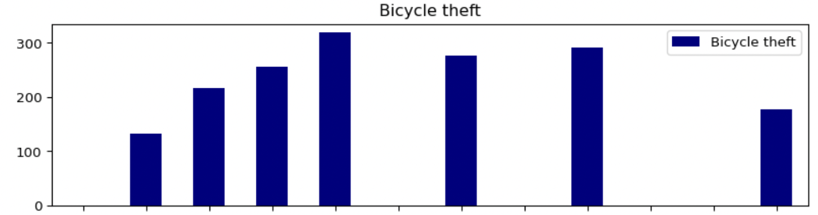



### Blaby 013C

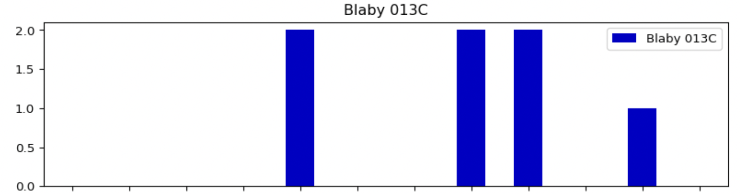



### Burglary

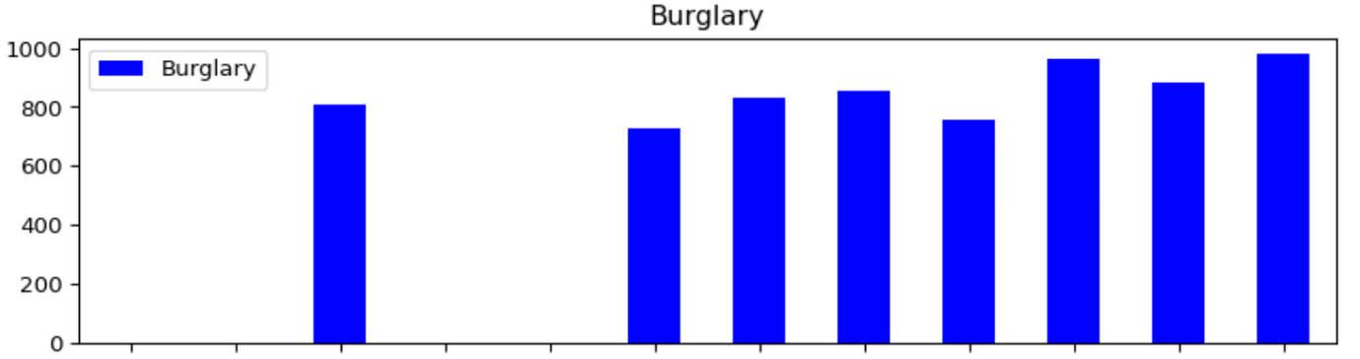



### Charnwood 012C

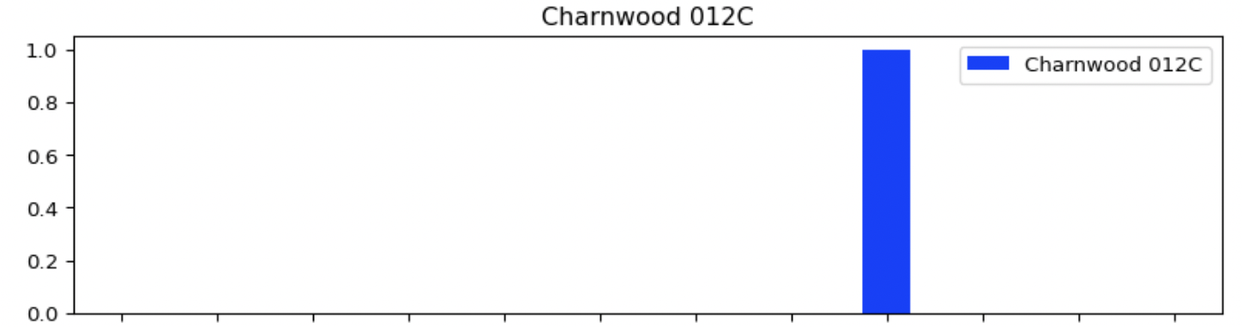



### Charnwood 021E

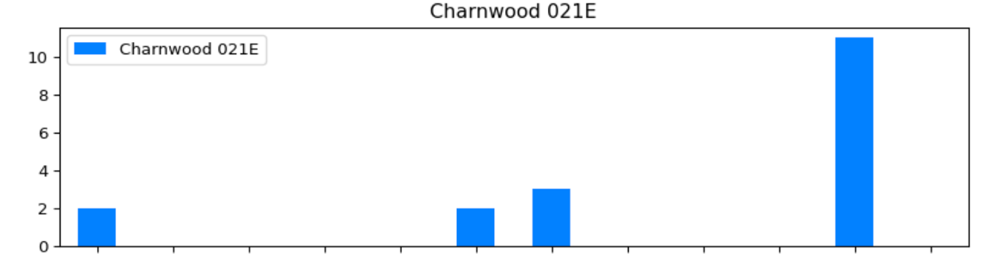



### Charnwood 022D

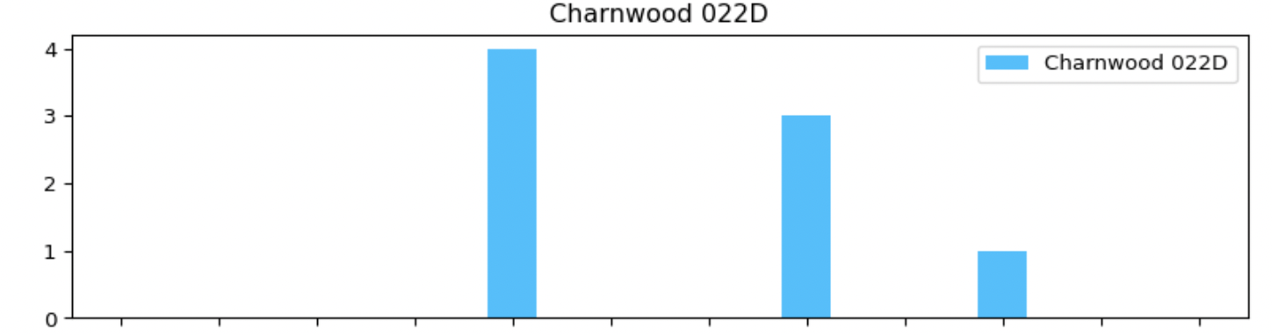



### Criminal damage and arson

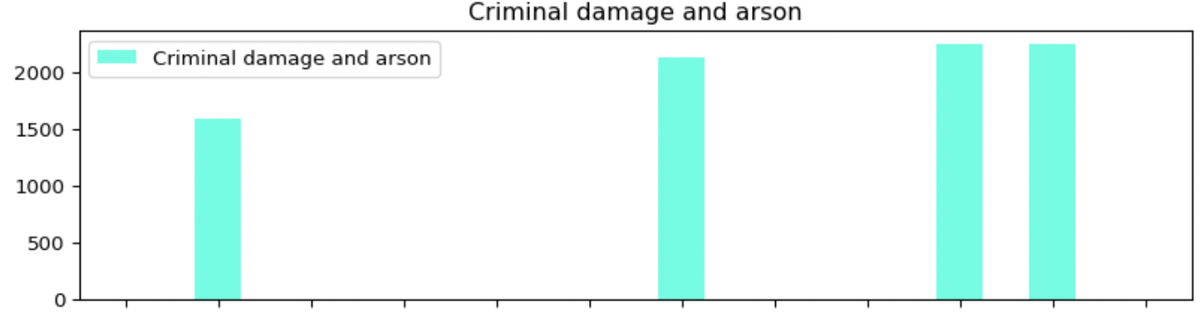



### Drugs

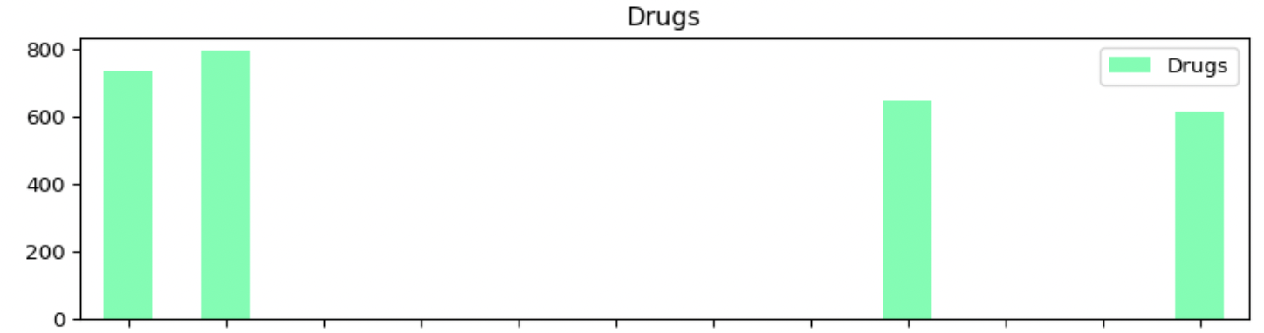



### Other crime

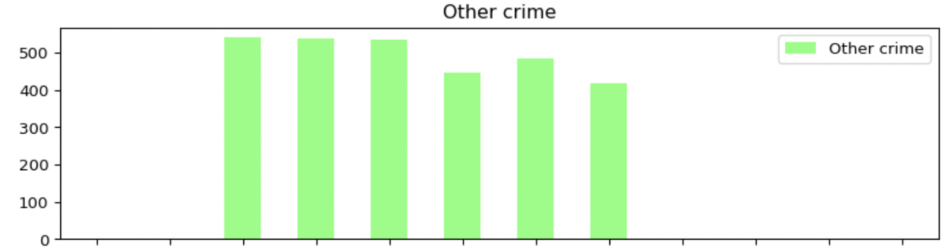



### Other theft

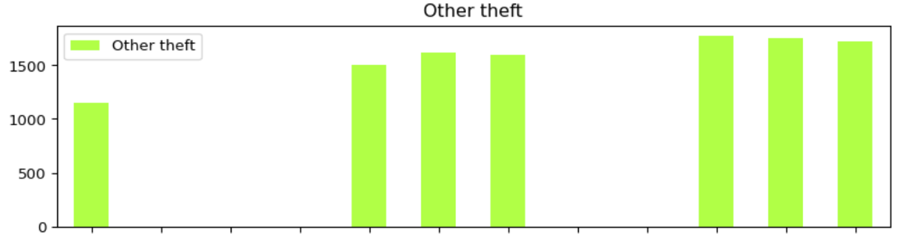



### Possession of weapons

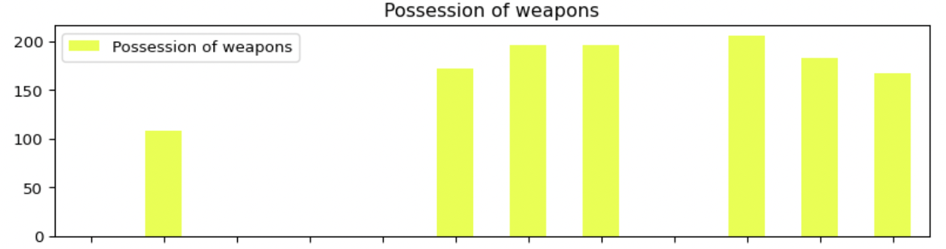



### Public order

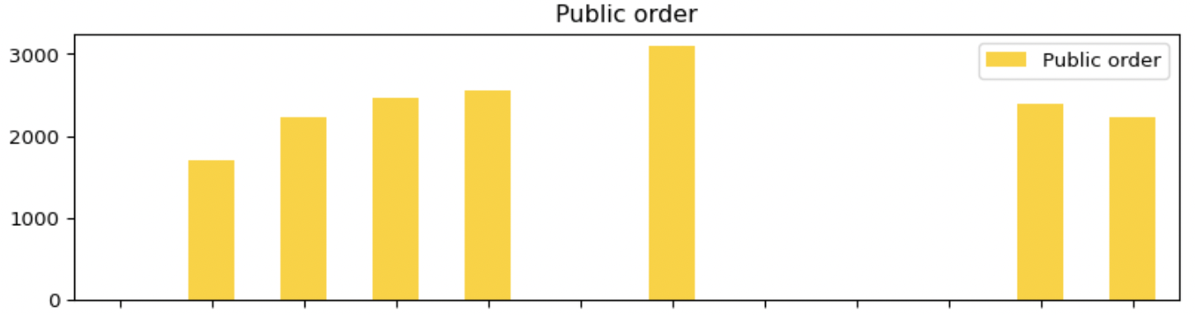



### Robbery

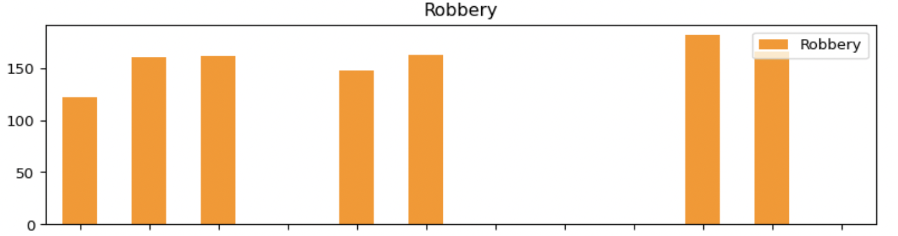



### Shoplifting

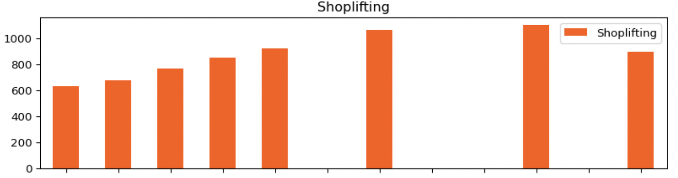



### Theft from the person

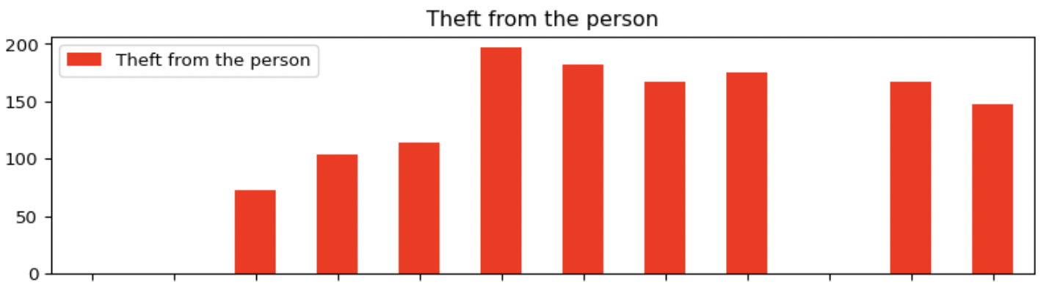



### Vehicle crime

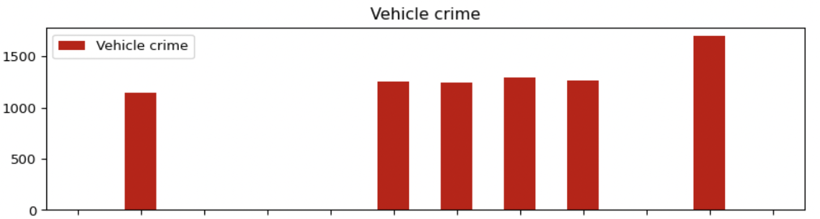



### Violence and sexual offences

